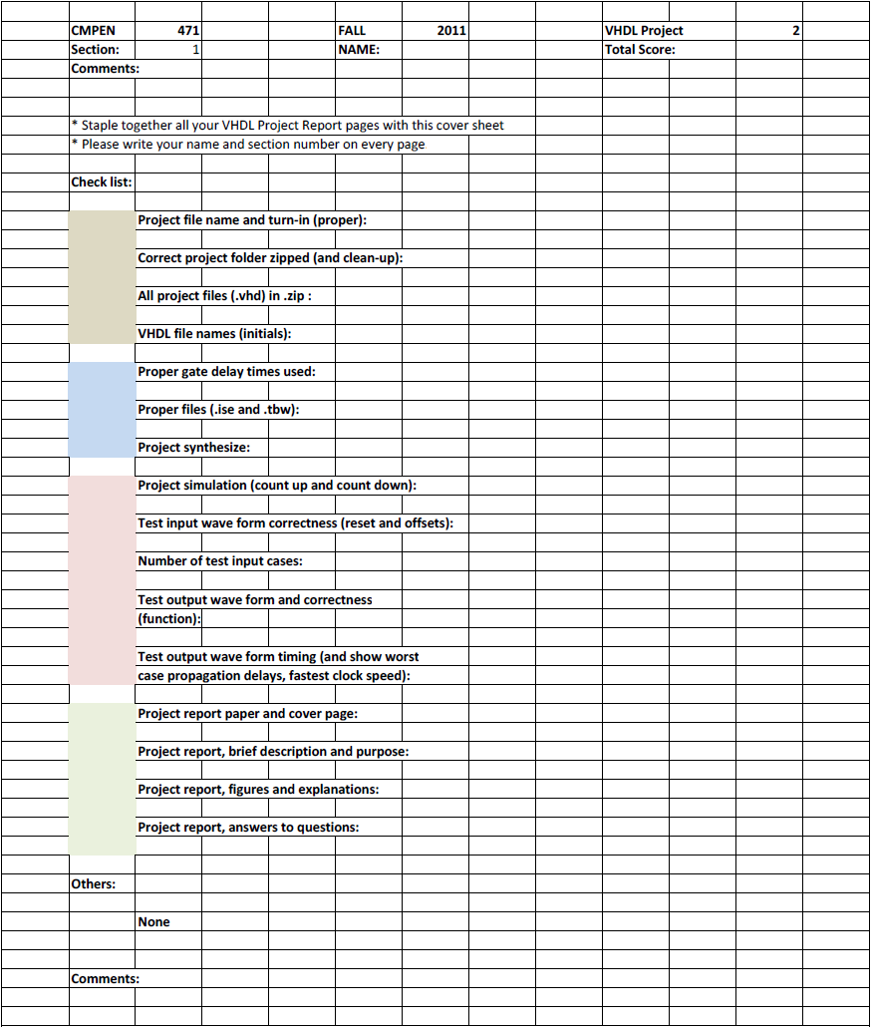
Erik Arfvidson
3

Erik Arfvidson
9/13/2012
Lab3
Project Report3

Questions
5. Do simulate the 6 bit PC and be sure that it is working properly. What is the maximum clock speed of your 6 bit PC in MHz, assuming 50% clock duty cycle?
The highest speed I was able to achieve was:1/1200ps=0.83ghz
12. When you complete the ROM implementation, do simulate the ROM and be sure that it is working properly. What is the ROM data access time (minimum signal propagation delay time from address signal to data output on the output buffer)? Can you change the address signal at this rate and access all 64 locations correctly, one by one? What is the data access time from 'csb' signal and from 'oeb' signal?

The highest speed I was able to achieve was:550ps=1.81Ghz
Theoretically it would be able to be done but in reality I would expect propagation delay to interfere.
I would expect the data acess time of a CSB and OEB to be around 550ps

13. 4 to 1 MUX: Implement a 4 to 1 MUX. Do simulate it and be sure that it is working properly. What is the maximum delay through your 4 to 1 MUX?
The highest speed I was able to achieve was:360ps=2.8GHz
14. Frequency Divider: Implement the Frequency Divider. You may design your own frequency divider circuit; however, it must be implemented in structural VHDL. Do simulate it and be sure that it is working properly. What is the maximum clock frequency for your frequency divider?
The highest speed I was able to achieve was:410ps=2.4Ghz
23. Determine the highest speed of operation: how fast can the signal ckm be clocked for your UFM?
The highest speed I was able to achieve was:160ps=6.25Ghz

Simulations
22. To verify the functioning of the UFM, design the test bench wave form ufm6bit_tbw1.tbw file. Your simulation must show counting up and counting down. Counting increments or decrements are the 6 bit 2's complement number applied to the B(5:0) input. Design the clock signal ckm at 500 MHz.

Description: As you can see at the beginning is counting up and then around 600 ns it starts counting down once again.
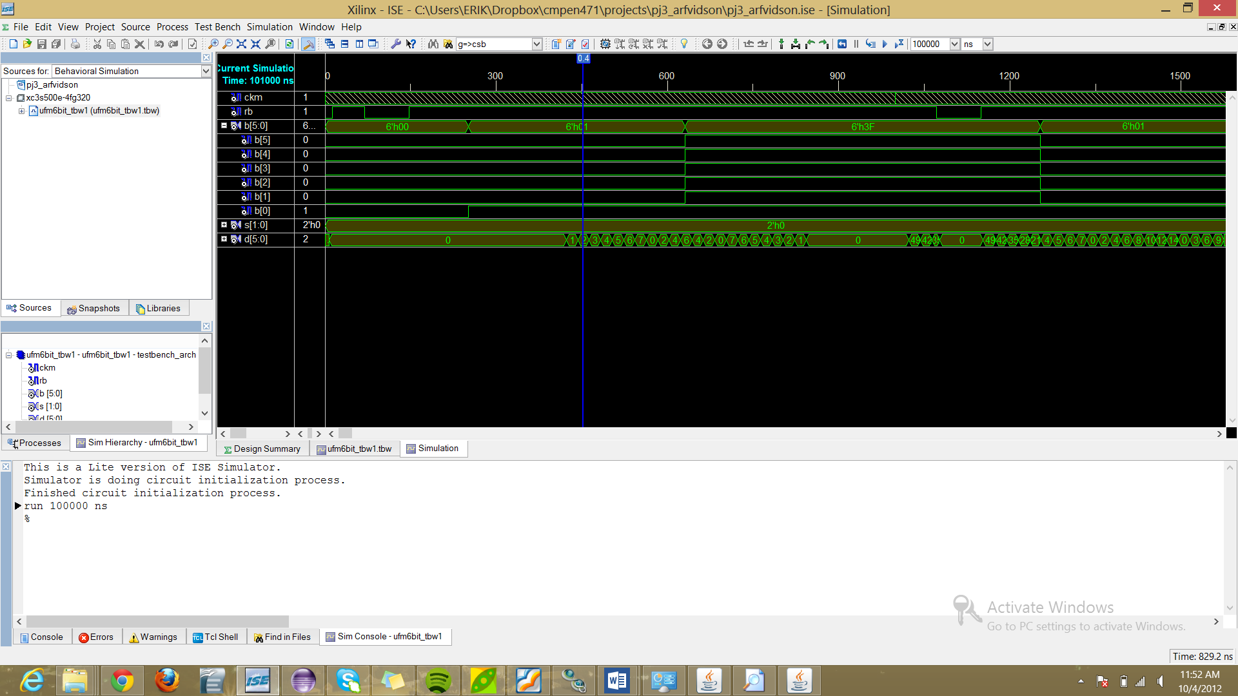

23. Design the test bench wave form ufm6bit_tbw2.tbw file. Your simulation must show worst case counting up and counting down. And design the clock signal ckm such that the UFM operates at maximum speed. Determine the highest speed of operation: how fast can the signal ckm be clocked
for your UFM?

Description:
The beginning is my worst case scenario counting up and then down and then around 500 ps I change the mux and show my best case scenario as you can see it quite faster.
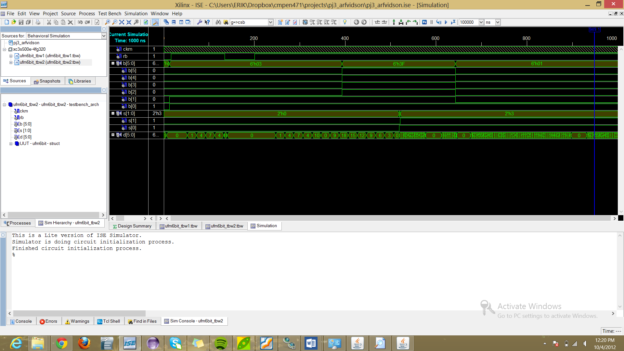

25.Frequency divider simulation
I successfully was able to create all the frequencies
D3: 50 Mhz
D2:100Mhz
D1:150Mhz
D0:250Mhz
